**Tableau**

**Project- 2**

Sales Performance

* No. of orders over years graph

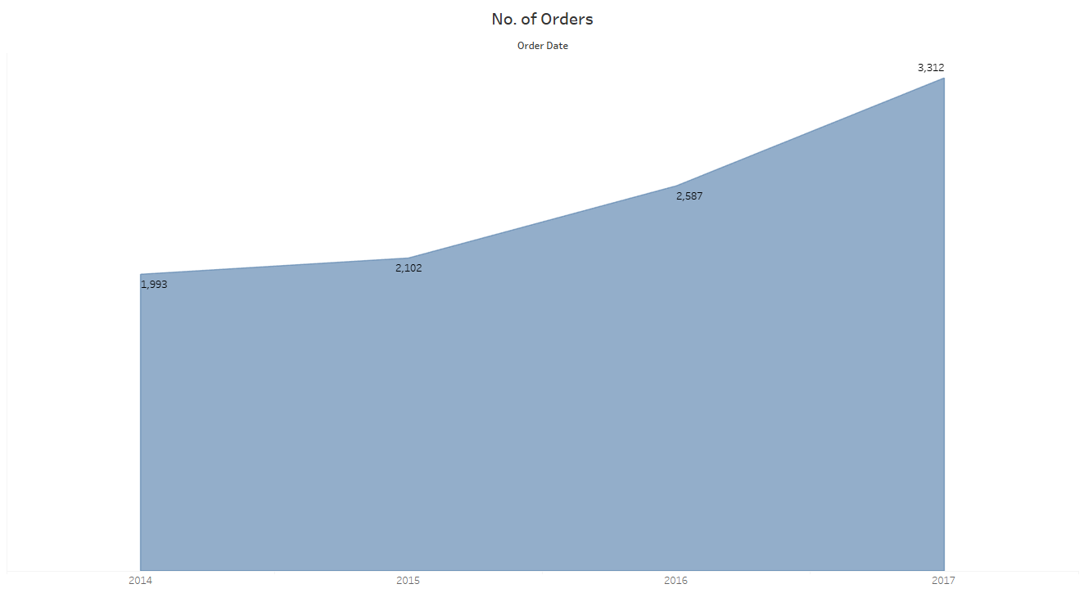

* Sales by segment and category

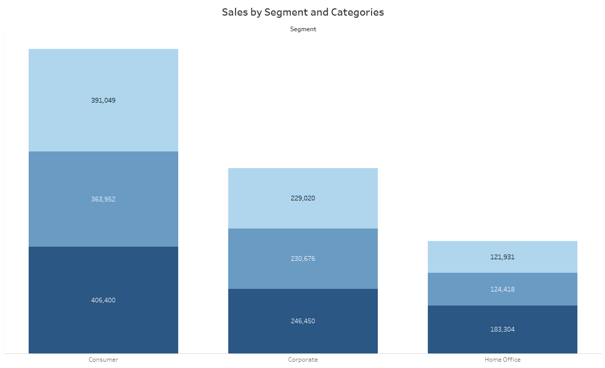

* Profit bin of 1k profit

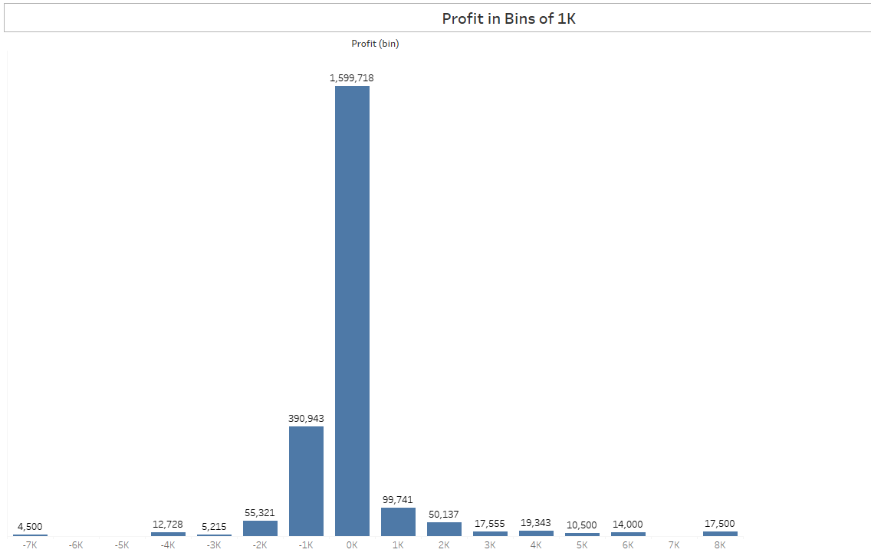

* KPI – Avg. time to deliver



* KPI – Avg. discount

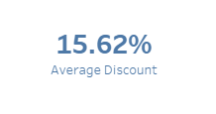

* KPI- Avg. order quantity

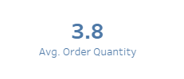

* No. of orders by region and category

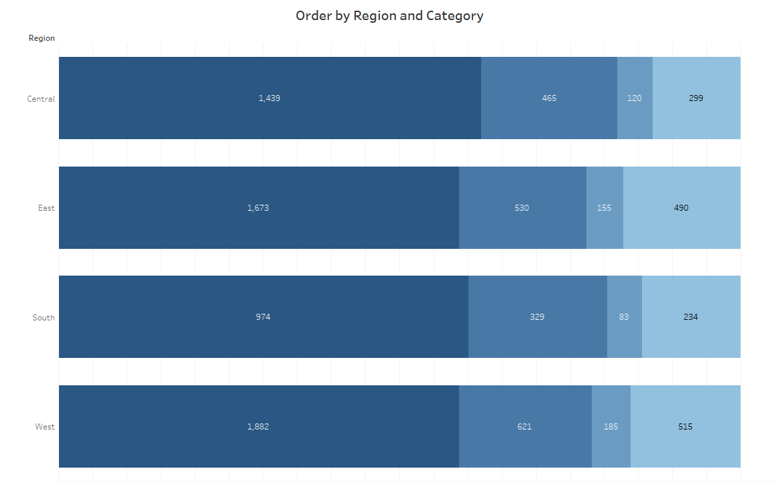

* Customer profit vs sales

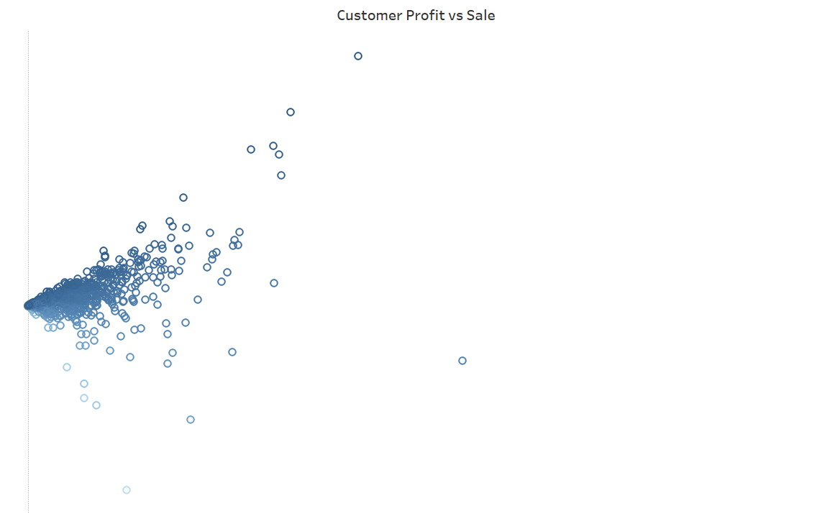

**Dashboard**

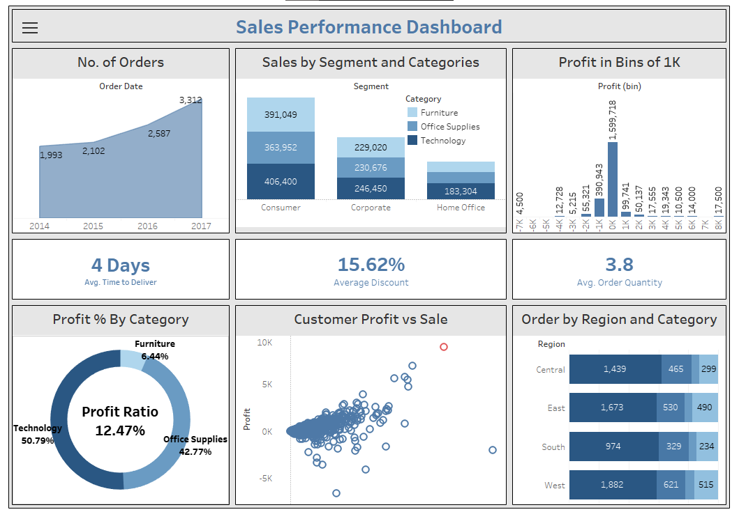

**Key Insights**

1. Highest No. of Orders, 3,312 Received in Year 2017
2. Highest Sales was in Consumer Segment
3. Lowest Sales was in Home Office Segment in Furniture Category
4. Highest Profit Received in 0-1000 Price Range
5. Average Time of Delivery is 4 Days
6. Average Discount is 15.62%
7. Average Order Quantity is 3.8
8. Overall Profit ratio is 12.47%
9. Profit Received in Different category:-

* Technology- 50.79%
* Office Supplies- 42.77%
* Furniture- 6.44%

1. Tamara Chand Received Highest Profit of 8,991 with Profit Ratio of 0.49

[**Project Link**](https://public.tableau.com/app/profile/pankaj.kumar8375/viz/TableauProjectSalesPerformance/SalesPerformanceDashboard?publish=yes)